**CS673S16 Software Engineering**

**Team X - Project Name**

**Software Design Document**



|  |  |  |  |
| --- | --- | --- | --- |
| Team Member | Role(s) | Signature | Date |
| Xiang Chen | Configuration Leader;  Integration Environment Leader | *Xiang Chen* | 10/24/2017 |
| Yansen Liu | Design leader | *Yansen Liu* | 10/26/2017 |
| Weicheng Yu | Backup Team Leader; Security Leader | *Weicheng Yu* | 10/26/2017 |
| Lu Min | QA Leader | *Lu Min* | 11/08/2017 |
|  |  |  |  |
|  |  |  |  |
|  |  |  |  |
|  |  |  |  |

**Revision history**

|  |  |  |  |
| --- | --- | --- | --- |
| **Version** | **Author** | **Date** | **Change** |
| **alpha** | **Team 3** | **10/30/2017** | **Complete main features** |
|  |  |  |  |

Introduction

Software Architecture

Design Patterns

Key Algorithms

Classes and Methods

References

Glossary

# Introduction (Weicheng)

In this section, give an overview of this document, and also address the design goals of your software system.

# Software Architecture (Yansen,Dawei,Xiang)

In this section, you will describe the decomposition of your software system, which include each component (which may be in terms of **package or folder**) and the **relationship** between components. (Yansen)

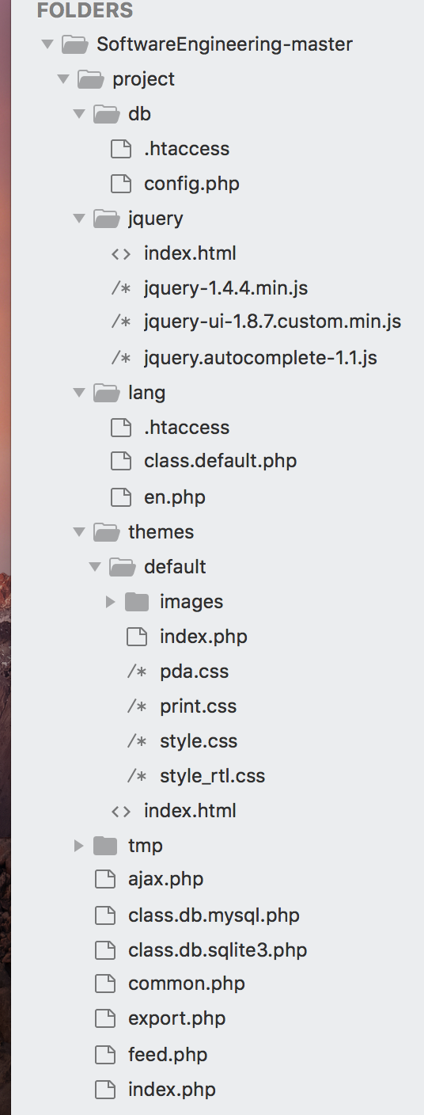

**Whole software architecture**

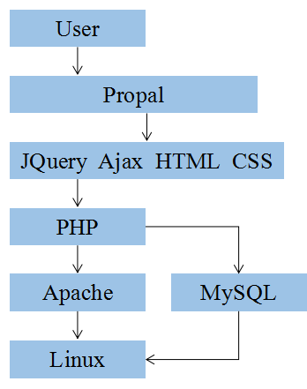

**Class diagram**

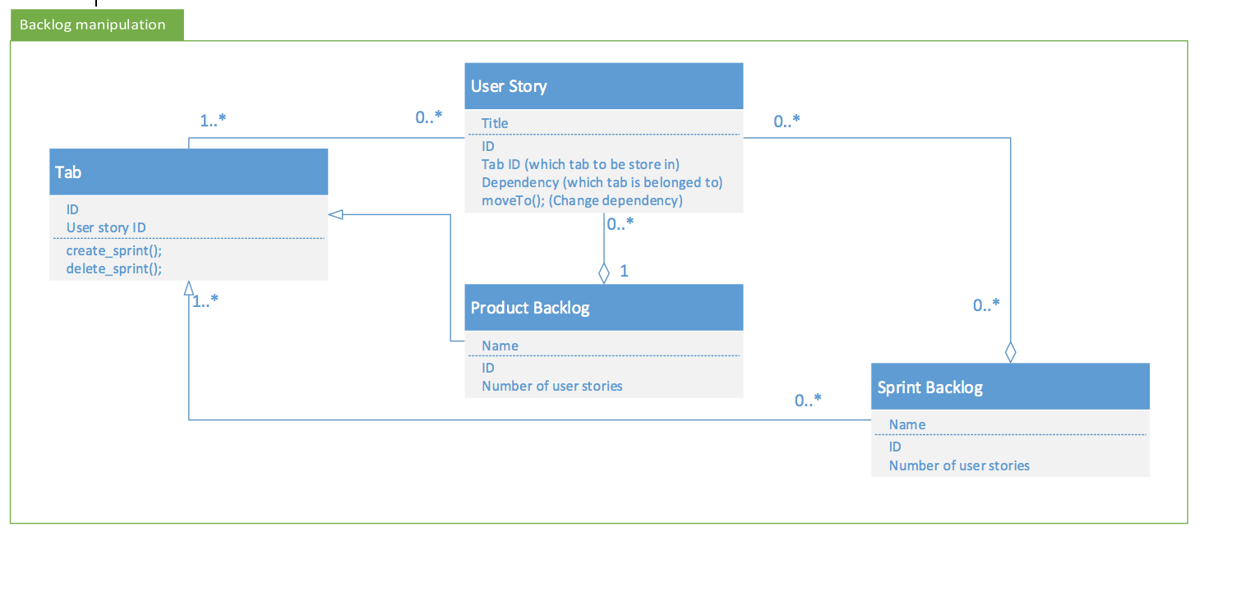

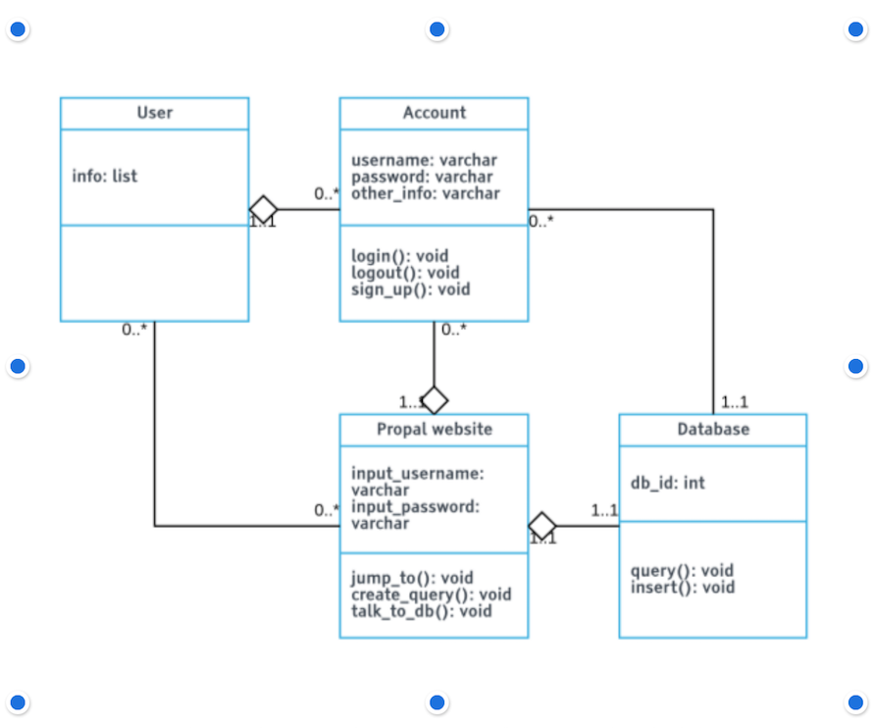

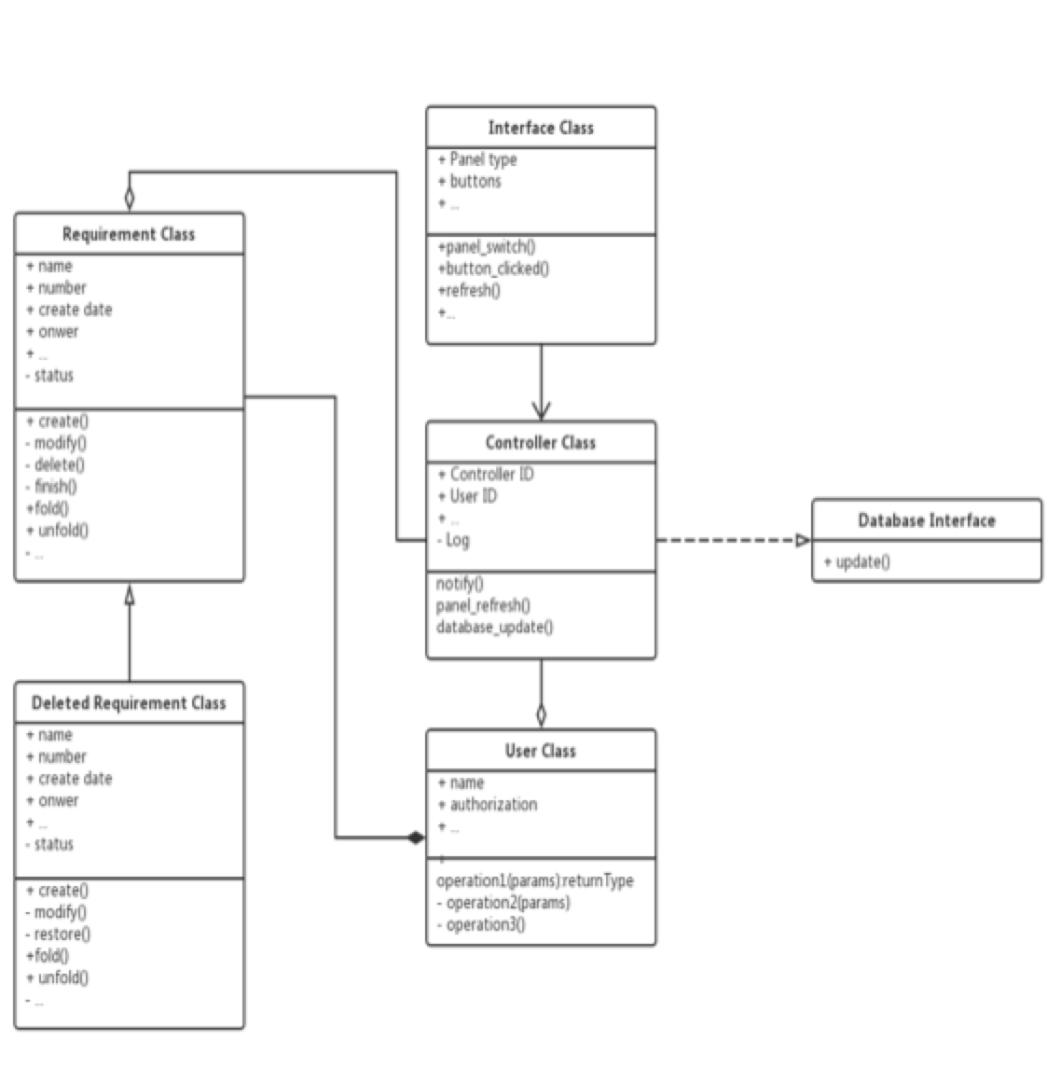

**The interface of each component and dependency between components**

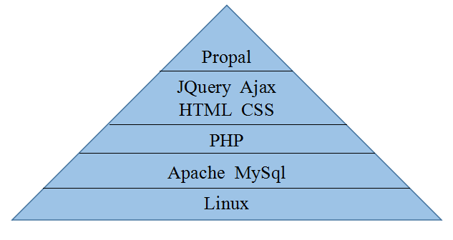

Dependency:

The basic in our software is the bottom one which is Linux system, everything were built on it. We use Mysql to build our database and use Apache to set our server. After this, we use PHP to start creating our software. We use Jquery, Ajax, HTML, and CSS based on PHP to design and create the application. And the top component is our web application: “Propal” which create by everything under it.

If any framework is used, it shall be defined here too. **Database design** should also be described if used. (Dawei Li)

**Database ER diagram (Dawei Li)**

Here is the database design ER diagram.

To user story: the Primary Key is ID. The day_created will be used to sort the user story by recording the day it is created. The point will be calculated and decided combining men hour.

To Tag: Primary key is Tag_id. Each user story could have a tag; also each task could have a tag.

To Sprint_tab: each user story must be located in a sprint tab.

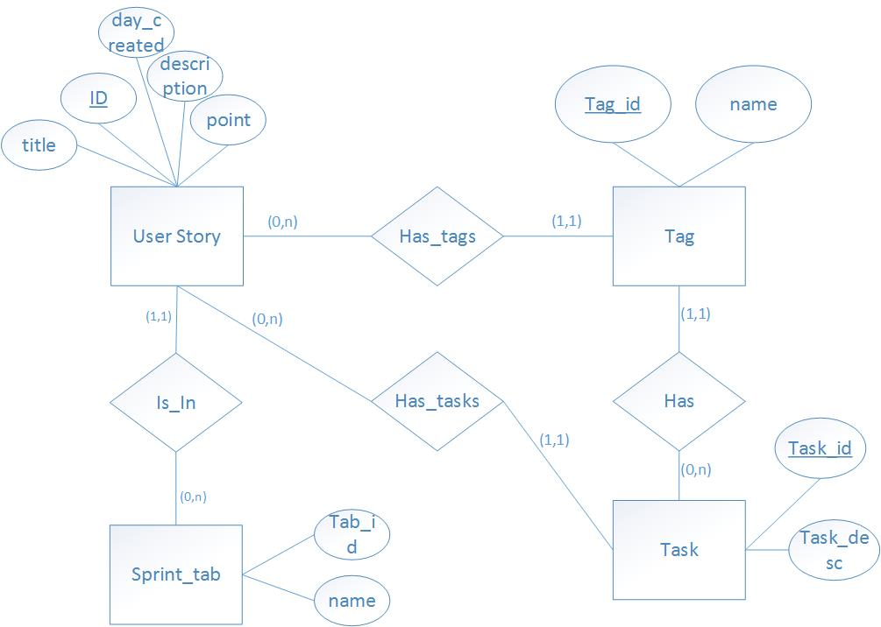

**Database schema(Dawei Li)**

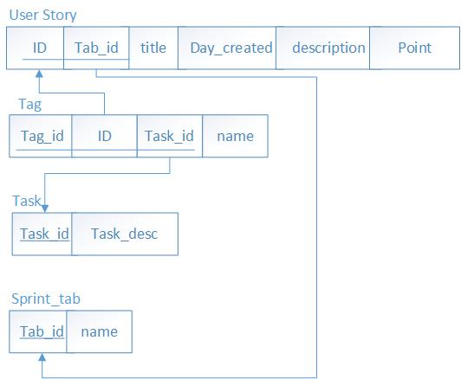

# Design Patterns (Weicheng, Yuhao(missing), Dawei)

**MVC design pattern(graphic) (Dawei Li)**

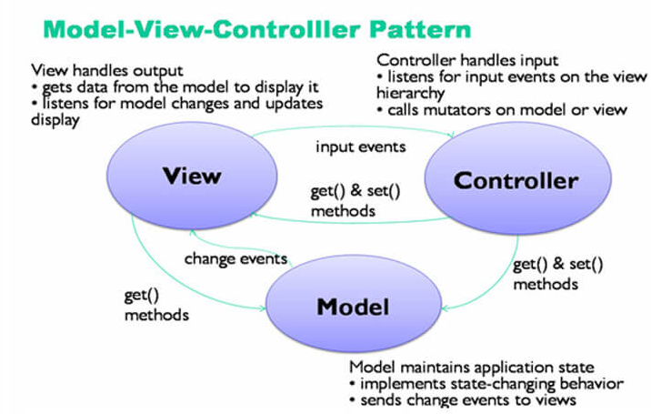

|  |  |  |
| --- | --- | --- |
| Model | View | Controller |
| Database | UI, Web Interface | Business Logic |
| MySQL | HTML,CSS,Javascript,JQuery | PHP |
| Store all the data | Present the front-end web page | Exchange data between Model and View |

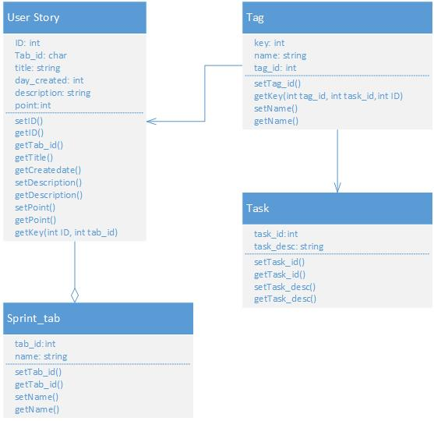

# Key Algorithms (Xiang)

In this section, you shall describe any key algorithms used in your software system, either in terms of pseudocode or flowchart.

**Sort Algorithm**

We need to sort all the user story by due date, thus we need sort algorithm

According to the picture below and our usage, we chose quicksort algorithm , which is O(nlogn) on average.

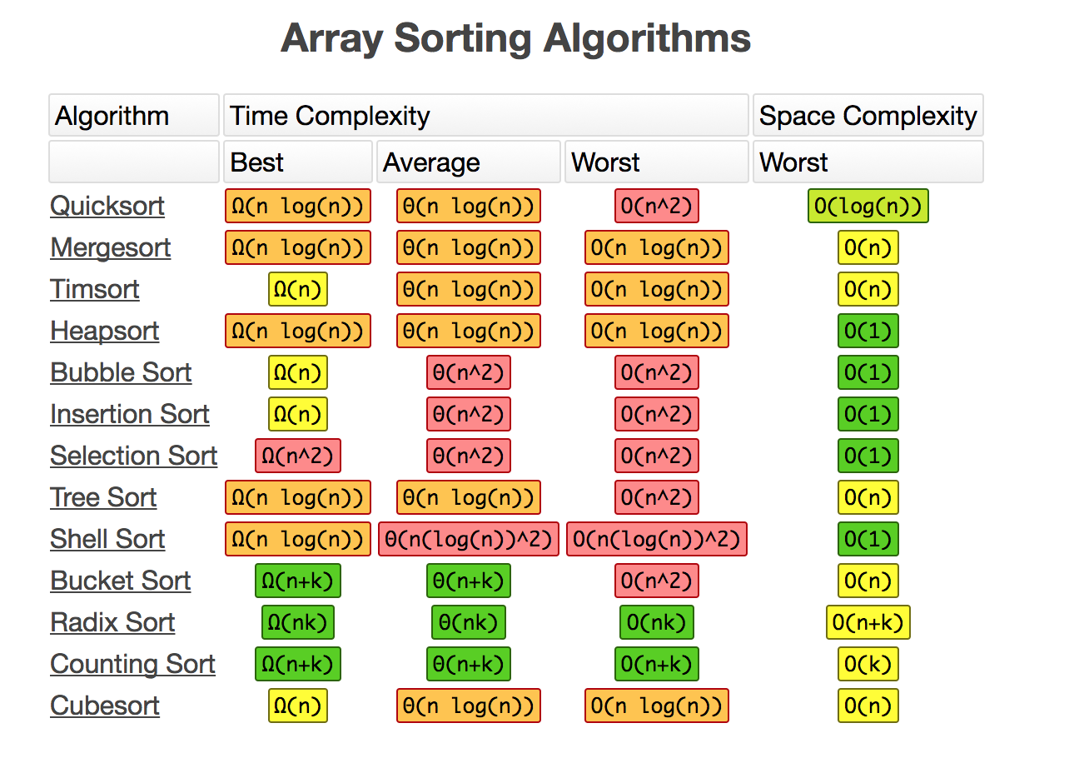

**Animation of Quicksort**



**Hash Algorithm**

We need to protect the privacy of user data, so we need to encrypt the sensitive data stored in the database. We choose to use SHA-1 Algorithm

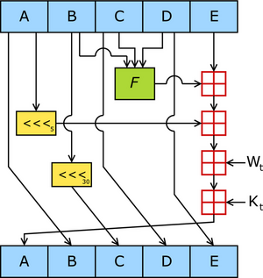

We leverage the sha function in php

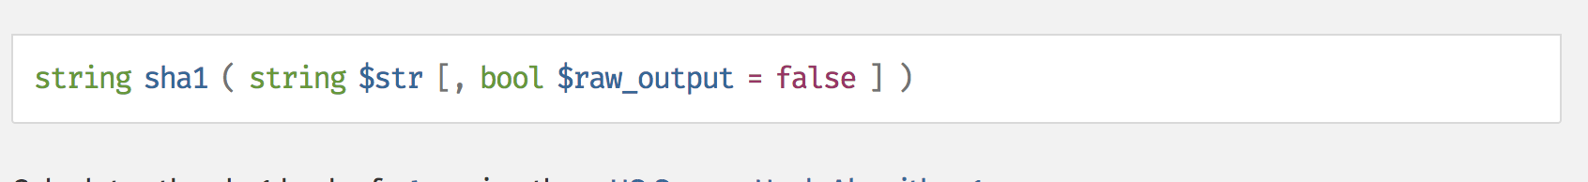

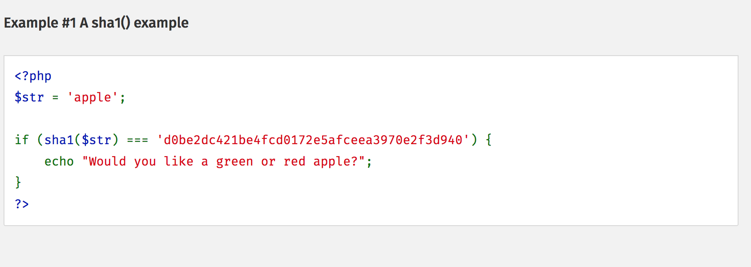

**String Matching and Parsing Algorithm**

We need to handle several case of string search and matching. In this project, we mainly used two kind of algorithms: KMP Algorithm (String Matching) and Regular Expression (String Parsing)

Knuth–Morris–Pratt string searching algorithm (or KMP algorithm) searches for occurrences of a "word" W within a main "text string" S by employing the observation that when a mismatch occurs, the word itself embodies sufficient information to determine where the next match could begin, thus bypassing re-examination of previously matched characters.

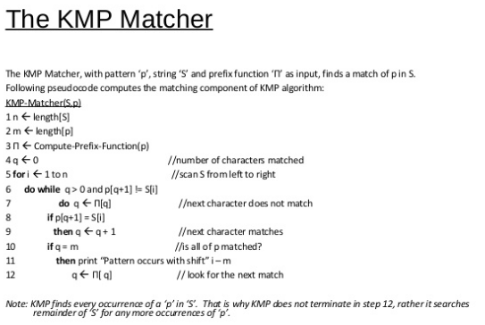

**Regular expression**

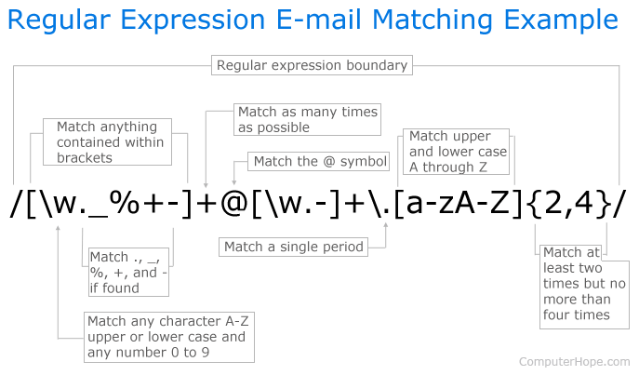

Used in PHP, example:

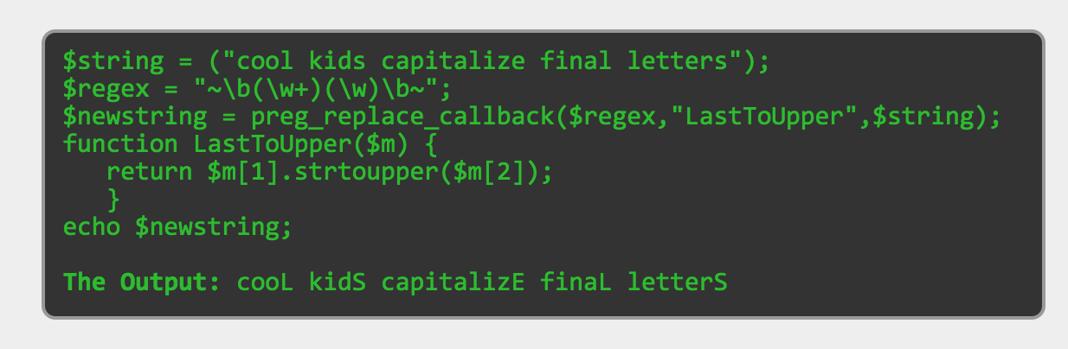

# Classes and Methods (Yansen, Chen Shou)

|  |  |  |  |  |
| --- | --- | --- | --- | --- |
| Method name | Author | Package | Version | Function |
| deleteStory() | Yansen Liu | project | α | Deleting story |
| completeStory() | Lu Min | project | α | Complete existing story |
| editStory() | Weicheng Yu | project | γ | Edit the detail of existing story |
| saveStory() | Weicheng Yu | project | α | Save story after changing |
| searchStory | Lu Min | project | β | Search for story |
| submitNewStory() | Yansen Liu | db | α | Add new story to story list |
| addList() | Weicheng Yu | db | γ | Add new sprint list by typing in ID |
| renameCurList() | Xiang Chen | db | α | Rename a sprint list |
| deleteCurList() | Weicheng Yu | db | β | Delete a sprint list from database |
| errorDenied() | Xiang Chen | style | β | Return “Access Denied” when error occur |
| deleteTask($id) | Chen Shou | style | α | Implement a story deletion function |
| moveTask($id,$listid) | Dawei Li | style | γ | Implement a story moving function |
| prepareTags($tagsStr) | Xiang Chen | pda | α | Assignments of tag and return tags created |
| getOrCreateTag($name) | Weicheng Yu | pda | γ | If no existence of tag for certain name create one, otherwise show the existing one |
| getTagid($tag) | Chen Shou | pda | γ | Get tag’s id according to tag given |
| get_task_tags($id) | Dawei Li | project | β | Get tag’s first row according to specific tag id |
| addTaskTags($taskid, $tagids, $listid) | Chen Shou | project | β | Add new tags on stories by typing in tags’ name |
| prepareList($row) | Weicheng Yu | project | α | Base on taskid, tagid, and listid, create task |
| prepareTaskRow($r) | Dawei Li | project | β | Get the most updated information from database schema taglist |
| check_write_access(listid=null) | Chen Shou | back | α | Check if the user has write access |

# References (All)

# Glossary